Coronavirus disease 2019 (COVID-19)
Situation Report – 67

Data as reported by national authorities by 10:00 CET 27 March 2020

HIGHLIGHTS
- Two new countries/territories/areas from the Region of the Americas [2] have reported cases of COVID-19.
- The total global number of COVID-19 cases has surpassed 500 000.
- Addressing the Extraordinary Summit on COVID-19, the WHO Director-General called on G20 leaders to fight, unite, and ignite against COVID-19. More information can be found here.
- WHO concluded the technical support mission to Egypt on 25 March 2020. More information can be found on the Eastern Mediterranean Regional Office site here.
- OpenWHO celebrates 1 million enrollments today. Seventy percent of the total enrollments are on COVID-19 resources, reflecting the critical role the platform is playing in supporting the response to the pandemic. On 25 March, a new course was launched describing how to design and operate treatment centres for the COVID-19 pandemic. COVID-19 resources are hosted on two learning channels: one for courses in official WHO languages here and a second for courses in additional national languages here.
- The number of countries implementing additional health measures that significantly interfere with international traffic has increased since the declaration of COVID-19 as a public health emergency of international concern. The United Nations World Tourism Organization launched a Crisis Committee to review the impact of the outbreak on the aviation, shipping and tourism sectors and propose innovative solutions for recovery. Greater detail can be found in Subject in Focus overleaf.
SITUATION IN NUMBERS
total (new) cases in last 24 hours

Globally
509 164 confirmed (46 484)
23 335 deaths (2501)
Western Pacific Region
100 018 confirmed (960)
3567 deaths (27)

European Region
286 697 confirmed (36 414)
16 105 deaths (2155)

South-East Asia Region
2932 confirmed (396)
105 deaths (26)

Eastern Mediterranean Region
35 249 confirmed (2807)
2336 deaths (174)

Region of the Americas
81 137 confirmed (5425)
1176 deaths (111)

African Region
2419 confirmed (482)
39 deaths (8)

WHO RISK ASSESSMENT
Global Level Very High

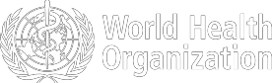
Figure 1. Countries, territories or areas with reported confirmed cases of COVID-19, 27 March 2020

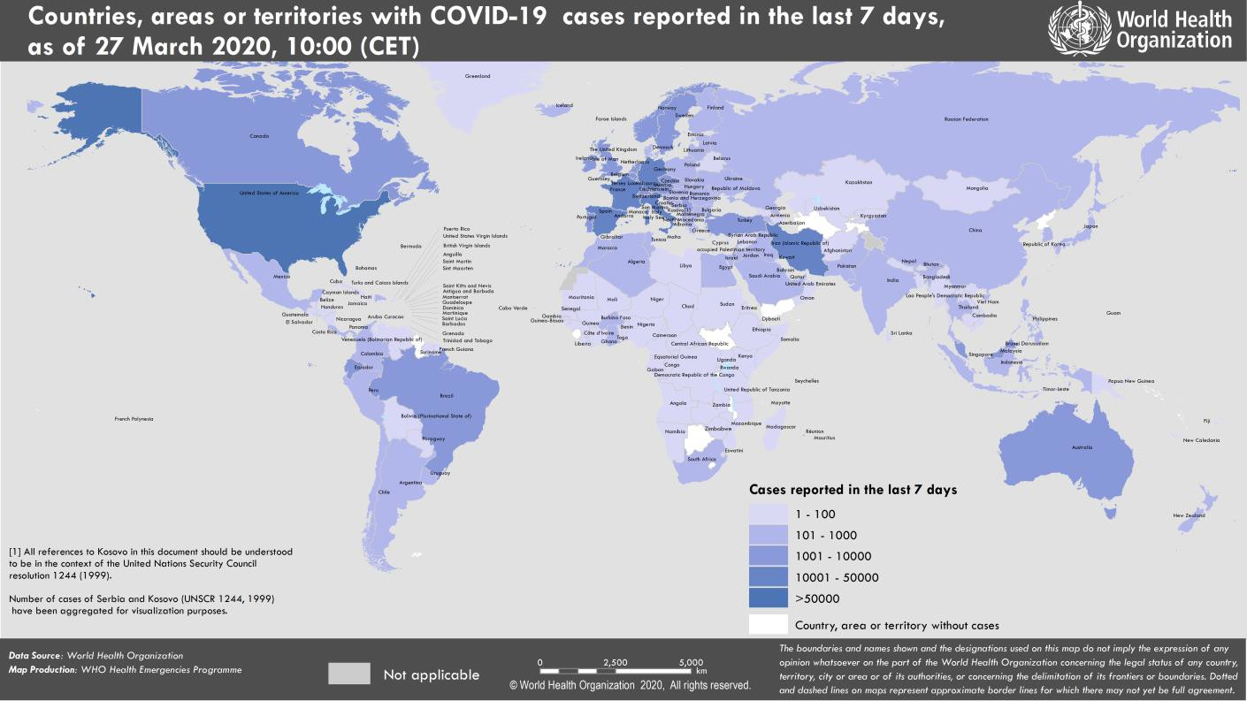

SUBJECT IN FOCUS: Additional health measures significantly interfere with international traffic

As of 25 March, 136 countries have implemented additional health measures that significantly interfere with international traffic as defined under Article 43 of the International Health Regulations (2005) (Table 1).

Table 1. Number of States Parties officially reporting additional health measures that significantly interfere with international traffic (i.e. more than 24h delay), under Article 43 of the IHR (2005) (by WHO region)

 | Announcement posted on the WHO Event Information Site (EIS) |  |  |  |  |  |  |  | TOTAL  new reports
WHO  Region | 6 Feb | 12 Feb | 21 Feb | 28 Feb | 5 Mar | 12 Mar | 19 Mar | 26 Mar
AFR | - | 1 | - | - | - | - | - | 22 (#)  1 update | 23
AMR | 10 | 2 | - | - | 1*  5* updates | 1 | 11  12 updates | 6  17 updates | 31
EMR | - | 1 | - | 1*  1* update | 1* | - | 1  1 update | 1 | 5
EUR | 2 | 1 | 2 | 5 (3*)  1* update | 2* | 5  3 updates | 18  19 updates | 6  20 updates | 41
SEAR | 1 | - | - | - | - | - | 6 | 4  8 updates | 11
WPR | 9 | 3 | 2 | 1* | - | 3 updates | 2 | 8 | 25
 |  |  |  | 6* | 8* | 3 updates | 4 updates | 12 updates | 25
 |  |  |  | updates | updates
TOTAL | 22 | 8 | 4 | 7 | 4 | 6 | 38 | 47 | 136
NOTE 1: numbers in parenthesis illustrate the number of reports – new or updates - received since previous announcement; NOTE 2: (*) designates that the State Party reports on measures directed to other countries in addition to China. Since 17 March, all countries report measures towards more than one country. NOTE 3: (#) Supporting document to be provided by Country or Regional Office. NOTE 4: AFR = African Region; AMR=Americas Region; EMR= Eastern Mediterranean Region; EUR= European Region; SEAR= South-East Asia Region; and WPR= Western Pacific Region

WHO has shared information with Member States every week since 6 February 2020 through the Event Information Site, a secure platform accessible by national IHR focal points and United Nations (UN) agencies. The majority of measures relate to the denial of entry of passengers from countries experiencing outbreaks, followed by flight suspensions, visa restrictions, border closures, and quarantine measures. Figure 1 shows the cumulative number of restrictions in relation to the time of the declaration of COVID-19 as a public health emergency of international concern (30 January 2020), and the characterization of the situation as a pandemic (11 March 2020).

Figure 1. Cumulative number of reported additional health measures

800
Cumulative # of reported measures

700

600
Pandemic

500

400

300
PHEIC

200

100

0
1/24/2020
1/26/2020
1/28/2020
1/30/2020
2/1/2020
2/3/2020
2/5/2020
2/7/2020
2/9/2020
2/11/2020
2/13/2020
2/15/2020
2/17/2020
2/19/2020
2/21/2020
2/23/2020
2/25/2020
2/27/2020
2/29/2020
3/2/2020
3/4/2020
3/6/2020
3/8/2020
3/10/2020
3/12/2020
3/14/2020
3/16/2020
3/18/2020
3/20/2020
3/22/2020
3/24/2020
3/26/2020

WHO has maintained weekly technical coordination with the aviation and tourism sectors. Interim guidance on the management of ill travellers at Points of Entry was published on 19 March. IATA recently published the third economic analysis, providing estimates of the economic impact of these travel restrictions. On 25 March, the UN World Tourism Organization launched a Crisis Committee, bringing together actors from the aviation, shipping and tourism sectors to review the impact of the outbreak on these sectors and propose innovative solutions for recovery. WHO has a technical advisory role in this committee.

SURVEILLANCE

Table 2. Countries, territories or areas with reported laboratory-confirmed COVID-19 cases and deaths. Data as of 27 March 2020*
Reporting Country/ Territory/Area† | Total confirmed  ‡ cases | Total confirmed new cases | Total deaths | Total new deaths | Transmission classification§ | Days since last reported case
Western Pacific Region
China | 82078 | 117 | 3298 | 5 | Local transmission | 0
Republic of Korea | 9332 | 91 | 139 | 8 | Local transmission | 0
Australia | 2985 | 186 | 13 | 2 | Local transmission | 0
Malaysia | 2031 | 235 | 23 | 4 | Local transmission | 0
Japan | 1387 | 96 | 46 | 1 | Local transmission | 0
Philippines | 707 | 71 | 45 | 7 | Local transmission | 0
Singapore | 683 | 52 | 2 | 0 | Local transmission | 0
New Zealand | 338 | 76 | 0 | 0 | Local transmission | 0
Viet Nam | 153 | 12 | 0 | 0 | Local transmission | 0
Brunei Darussalam | 114 | 5 | 0 | 0 | Local transmission | 0
Cambodia | 98 | 2 | 0 | 0 | Local transmission | 0
Mongolia | 11 | 1 | 0 | 0 | Imported cases only | 0
Lao People's Democratic Republic | 6 | 3 | 0 | 0 | Under investigation | 0
Fiji | 5 | 0 | 0 | 0 | Local transmission | 1
Papua New Guinea | 1 | 0 | 0 | 0 | Imported cases only | 6
Territories**
Guam | 45 | 8 | 1 | 0 | Local transmission | 0
French Polynesia | 30 | 5 | 0 | 0 | Local transmission | 0
New Caledonia | 14 | 0 | 0 | 0 | Local transmission | 1
European Region
Italy | 80539 | 6153 | 8165 | 660 | Local transmission | 0
Spain | 56188 | 8578 | 4089 | 655 | Local transmission | 0
Germany | 42288 | 5780 | 253 | 55 | Local transmission | 0
France | 28786 | 3866 | 1695 | 364 | Local transmission | 0
The United Kingdom | 11662 | 2129 | 578 | 115 | Local transmission | 0
Switzerland | 10714 | 1000 | 161 | 58 | Local transmission | 0
Netherlands | 7431 | 1019 | 434 | 78 | Local transmission | 0
Austria | 7029 | 1141 | 52 | 18 | Local transmission | 0
Belgium | 6235 | 1298 | 220 | 42 | Local transmission | 0
Turkey | 3629 | 1196 | 75 | 16 | Local transmission | 0
Portugal | 3544 | 549 | 60 | 17 | Local transmission | 0
Norway | 3156 | 240 | 14 | 2 | Local transmission | 0
Israel | 3035 | 666 | 10 | 5 | Local transmission | 0
Sweden | 2806 | 296 | 66 | 24 | Local transmission | 0
Czechia | 2062 | 408 | 9 | 3 | Local transmission | 0
Denmark | 1877 | 153 | 41 | 7 | Local transmission | 0
Ireland | 1819 | 255 | 19 | 10 | Local transmission | 0
Luxembourg | 1453 | 120 | 9 | 1 | Local transmission | 0
Poland | 1221 | 170 | 16 | 2 | Local transmission | 0
Russian Federation | 1036 | 196 | 3 | 1 | Local transmission | 0
Romania | 1029 | 123 | 17 | 4 | Local transmission | 0
Finland | 958 | 78 | 4 | 1 | Local transmission | 0
Greece | 892 | 71 | 26 | 4 | Local transmission | 0
Iceland | 802 | 65 | 2 | 0 | Local transmission | 0
Slovenia | 577 | 49 | 5 | 1 | Local transmission | 0

Estonia | 538 | 134 | 1 | 0 | Local transmission | 0
Croatia | 495 | 77 | 2 | 1 | Local transmission | 0
Serbia | 457 | 73 | 7 | 3 | Local transmission | 0
Armenia | 329 | 39 | 1 | 1 | Local transmission | 0
Hungary | 300 | 39 | 10 | 0 | Local transmission | 0
Lithuania | 299 | 25 | 4 | 0 | Local transmission | 0
Bulgaria | 264 | 22 | 3 | 0 | Local transmission | 0
Latvia | 244 | 23 | 0 | 0 | Local transmission | 0
Andorra | 231 | 18 | 3 | 0 | Local transmission | 0
Slovakia | 226 | 10 | 0 | 0 | Local transmission | 0
San Marino | 218 | 10 | 21 | 0 | Local transmission | 0
Ukraine | 218 | 62 | 5 | 0 | Local transmission | 0
Bosnia and Herzegovina | 213 | 40 | 3 | 0 | Local transmission | 0
North Macedonia | 201 | 24 | 3 | 1 | Local transmission | 0
Albania | 186 | 12 | 8 | 3 | Local transmission | 0
Republic of Moldova | 177 | 28 | 2 | 1 | Local transmission | 0
Cyprus | 146 | 14 | 3 | 0 | Local transmission | 0
Malta | 134 | 5 | 0 | 0 | Local transmission | 0
Kazakhstan | 125 | 28 | 0 | 0 | Imported cases only | 0
Azerbaijan | 122 | 29 | 3 | 1 | Local transmission | 0
Belarus | 86 | 0 | 0 | 0 | Local transmission | 1
Uzbekistan | 83 | 18 | 0 | 0 | Local transmission | 0
Georgia | 81 | 4 | 0 | 0 | Local transmission | 0
Montenegro | 67 | 15 | 1 | 0 | Local transmission | 0
Kyrgyzstan | 58 | 14 | 0 | 0 | Local transmission | 0
Liechtenstein | 56 | 5 | 0 | 0 | Imported cases only | 0
Monaco | 19 | 0 | 0 | 0 | Local transmission | 4
Holy See | 4 | 0 | 0 | 0 | Under investigation | 1
Territories**
Faroe Islands | 140 | 8 | 0 | 0 | Local transmission | 0
Kosovo[1] | 79 | 8 | 1 | 0 | Local transmission | 0
Gibraltar | 35 | 9 | 0 | 0 | Local transmission | 0
Guernsey | 34 | 4 | 0 | 0 | Local transmission | 0
Jersey | 32 | 14 | 1 | 1 | Local transmission | 0
Isle of Man | 26 | 3 | 0 | 0 | Local transmission | 0
Greenland | 6 | 1 | 0 | 0 | Under investigation | 0
South-East Asia Region
Thailand | 1136 | 202 | 5 | 1 | Local transmission | 0
Indonesia | 893 | 103 | 78 | 20 | Local transmission | 0
India | 724 | 75 | 17 | 4 | Local transmission | 0
Sri Lanka | 106 | 4 | 0 | 0 | Local transmission | 0
Bangladesh | 48 | 9 | 5 | 1 | Local transmission | 0
Maldives | 13 | 0 | 0 | 0 | Local transmission | 11
Myanmar | 5 | 2 | 0 | 0 | Imported cases only | 0
Bhutan | 3 | 1 | 0 | 0 | Imported cases only | 0
Nepal | 3 | 0 | 0 | 0 | Imported cases only | 1
Timor-Leste | 1 | 0 | 0 | 0 | Imported cases only | 6
Eastern Mediterranean Region
Iran (Islamic Republic of) | 29406 | 2389 | 2234 | 157 | Local transmission | 0
Pakistan | 1057 | 0 | 8 | 0 | Local transmission | 1
Saudi Arabia | 1012 | 112 | 3 | 1 | Local transmission | 0
Qatar | 549 | 12 | 0 | 0 | Local transmission | 0

Egypt | 495 | 39 | 24 | 3 | Local transmission | 0
Bahrain | 458 | 39 | 4 | 0 | Local transmission | 0
Iraq | 382 | 36 | 36 | 7 | Local transmission | 0
Lebanon | 368 | 35 | 6 | 2 | Local transmission | 0
United Arab Emirates | 333 | 0 | 2 | 0 | Local transmission | 1
Morocco | 275 | 50 | 10 | 4 | Local transmission | 0
Jordan | 212 | 40 | 0 | 0 | Local transmission | 0
Kuwait | 208 | 0 | 0 | 0 | Local transmission | 1
Tunisia | 197 | 24 | 5 | 0 | Local transmission | 0
Oman | 109 | 10 | 0 | 0 | Local transmission | 0
Afghanistan | 80 | 0 | 2 | 0 | Local transmission | 1
Djibouti | 12 | 0 | 0 | 0 | Local transmission | 1
Syrian Arab Republic | 5 | 0 | 0 | 0 | Imported cases only | 1
Somalia | 3 | 1 | 0 | 0 | Imported cases only | 0
Sudan | 3 | 0 | 1 | 0 | Imported cases only | 2
Libya | 1 | 0 | 0 | 0 | Imported cases only | 2
Territories**
occupied Palestinian territory | 84 | 20 | 1 | 0 | Local transmission | 0
Region of the Americas
United States of America | 68334 | 4764 | 991 | 107 | Local transmission | 0
Canada | 3555 | 146 | 35 | 0 | Local transmission | 0
Brazil | 2433 | 0 | 57 | 0 | Local transmission | 1
Chile | 1306 | 164 | 4 | 1 | Local transmission | 0
Ecuador | 1211 | 0 | 29 | 0 | Local transmission | 1
Peru | 580 | 100 | 9 | 0 | Local transmission | 0
Panama | 558 | 0 | 8 | 0 | Local transmission | 1
Argentina | 502 | 115 | 8 | 2 | Local transmission | 0
Dominican Republic | 488 | 96 | 10 | 0 | Local transmission | 0
Mexico | 478 | 0 | 5 | 0 | Local transmission | 1
Colombia | 470 | 0 | 4 | 0 | Local transmission | 1
Uruguay | 217 | 0 | 0 | 0 | Imported cases only | 1
Costa Rica | 201 | 0 | 2 | 0 | Local transmission | 1
Venezuela (Bolivarian Republic of) | 91 | 0 | 0 | 0 | Local transmission | 1
Cuba | 67 | 10 | 1 | 0 | Local transmission | 0
Trinidad and Tobago | 61 | 1 | 1 | 0 | Local transmission | 0
Honduras | 52 | 0 | 1 | 1 | Local transmission | 1
Paraguay | 41 | 0 | 3 | 0 | Local transmission | 1
Bolivia (Plurinational State of) | 39 | 0 | 0 | 0 | Local transmission | 1
Jamaica | 26 | 0 | 1 | 0 | Local transmission | 1
Guatemala | 24 | 0 | 1 | 0 | Local transmission | 1
Barbados | 18 | 0 | 0 | 0 | Local transmission | 2
El Salvador | 13 | 0 | 0 | 0 | Imported cases only | 1
Dominica | 11 | 4 | 0 | 0 | Local transmission | 0
Haiti | 8 | 0 | 0 | 0 | Imported cases only | 1
Grenada | 7 | 6 | 0 | 0 | Local transmission | 0
Suriname | 7 | 0 | 0 | 0 | Imported cases only | 1
Bahamas | 5 | 0 | 0 | 0 | Local transmission | 1
Guyana | 5 | 0 | 1 | 0 | Local transmission | 8
Antigua and Barbuda | 3 | 0 | 0 | 0 | Imported cases only | 2
Saint Lucia | 3 | 0 | 0 | 0 | Imported cases only | 3

Belize | 2 | 0 | 0 | 0 | Local transmission | 1
Nicaragua | 2 | 0 | 0 | 0 | Imported cases only | 5
Saint Kitts and Nevis | 2 | 0 | 0 | 0 | Imported cases only | 1
Saint Vincent and the Grenadines | 1 | 0 | 0 | 0 | Imported cases only | 14
Territories**
Guadeloupe | 76 | 0 | 0 | 0 | Imported cases only | 1
Martinique | 66 | 0 | 1 | 0 | Imported cases only | 1
Puerto Rico | 64 | 13 | 2 | 0 | Imported cases only | 0
French Guiana | 28 | 0 | 0 | 0 | Local transmission | 1
Aruba | 19 | 0 | 0 | 0 | Local transmission | 1
United States Virgin Islands | 17 | 0 | 0 | 0 | Imported cases only | 3
Saint Martin | 11 | 0 | 0 | 0 | Under investigation | 1
Cayman Islands | 8 | 0 | 1 | 0 | Imported cases only | 1
Bermuda | 7 | 0 | 0 | 0 | Local transmission | 1
Curaçao | 7 | 1 | 1 | 0 | Imported cases only | 0
Saint Barthélemy | 3 | 0 | 0 | 0 | Under investigation | 11
Anguilla | 2 | 2 | 0 | 0 | Local transmission | 0
British Virgin Islands | 2 | 2 | 0 | 0 | Imported cases only | 0
Montserrat | 2 | 0 | 0 | 0 | Imported cases only | 1
Sint Maarten | 2 | 0 | 0 | 0 | Imported cases only | 3
Turks and Caicos Islands | 2 | 1 | 0 | 0 | Imported cases only | 0
African Region
South Africa | 927 | 218 | 0 | 0 | Local transmission | 0
Algeria | 305 | 41 | 21 | 4 | Local transmission | 0
Burkina Faso | 146 | 0 | 3 | 0 | Local transmission | 1
Ghana | 132 | 64 | 3 | 1 | Local transmission | 0
Senegal | 105 | 6 | 0 | 0 | Local transmission | 0
Mauritius | 81 | 34 | 2 | 0 | Imported cases only | 0
Côte d’Ivoire | 80 | 0 | 0 | 0 | Imported cases only | 1
Cameroon | 75 | 5 | 1 | 0 | Local transmission | 0
Nigeria | 65 | 19 | 1 | 0 | Local transmission | 0
Democratic Republic of the Congo | 54 | 3 | 4 | 1 | Local transmission | 0
Rwanda | 50 | 9 | 0 | 0 | Local transmission | 0
Kenya | 25 | 0 | 1 | 1 | Local transmission | 2
Madagascar | 24 | 5 | 0 | 0 | Imported cases only | 0
Togo | 24 | 1 | 0 | 0 | Imported cases only | 0
Uganda | 14 | 0 | 0 | 0 | Imported cases only | 1
United Republic of Tanzania | 13 | 0 | 0 | 0 | Imported cases only | 1
Ethiopia | 12 | 0 | 0 | 0 | Imported cases only | 2
Niger | 10 | 8 | 1 | 1 | Imported cases only | 0
Namibia | 8 | 3 | 0 | 0 | Imported cases only | 0
Seychelles | 7 | 0 | 0 | 0 | Imported cases only | 5
Benin | 6 | 1 | 0 | 0 | Imported cases only | 0
Equatorial Guinea | 6 | 0 | 0 | 0 | Imported cases only | 5
Eritrea | 6 | 2 | 0 | 0 | Imported cases only | 0
Eswatini | 6 | 2 | 0 | 0 | Imported cases only | 0
Gabon | 6 | 0 | 1 | 0 | Imported cases only | 4
Central African Republic | 5 | 0 | 0 | 0 | Imported cases only | 1

Chad | 5 | 2 | 0 | 0 | Imported cases only | 0
Guinea | 5 | 1 | 0 | 0 | Imported cases only | 0
Mozambique | 5 | 0 | 0 | 0 | Local transmission | 1
Congo | 4 | 0 | 0 | 0 | Imported cases only | 5
Cabo Verde | 3 | 0 | 0 | 0 | Imported cases only | 5
Liberia | 3 | 0 | 0 | 0 | Local transmission | 5
Mauritania | 3 | 1 | 0 | 0 | Imported cases only | 0
Zambia | 3 | 0 | 0 | 0 | Imported cases only | 4
Zimbabwe | 3 | 1 | 1 | 0 | Imported cases only | 0
Angola | 2 | 0 | 0 | 0 | Imported cases only | 5
Gambia | 2 | 0 | 0 | 0 | Imported cases only | 2
Guinea-Bissau | 2 | 0 | 0 | 0 | Imported cases only | 1
Mali | 2 | 0 | 0 | 0 | Imported cases only | 1
Territories**
Réunion | 135 | 41 | 0 | 0 | Local transmission | 0
Mayotte | 50 | 15 | 0 | 0 | Local transmission | 0
Subtotal for all regions | 508452 | 46484 | 23328 | 2501
International conveyance (Diamond Princess) | 712 | 0 | 7 | 0 | Local transmission | 11
Grand total | 509164 | 46484 | 23335 | 2501
*Numbers include both domestic and repatriated cases
†The designations employed and the presentation of the material in this publication do not imply the expression of any opinion whatsoever on the part of WHO concerning the legal status of any country, territory, city or area or of its authorities, or concerning the delimitation of its frontiers or boundaries. Dotted and dashed lines on maps represent approximate border lines for which there may not yet be full agreement.
‡Case classifications are based on WHO case definitions for COVID-19.
§Transmission classification is based on WHO analysis of available official data and may be subject to reclassification as additional data become available. Countries/territories/areas experiencing multiple types of transmission are classified in the highest category for which there is evidence; they may be removed from a given category if interruption of transmission can be demonstrated. It should be noted that even within categories, different countries/territories/areas may have differing degrees of transmission as indicated by the differing numbers of cases and other factors. Not all locations within a given country/territory/area are equally affected.
Terms:
- Community transmission is evidenced by the inability to relate confirmed cases through chains of transmission for a large number of cases, or by increasing positive tests through sentinel samples (routine systematic testing of respiratory samples from established laboratories).
- Local transmission indicates locations where the source of infection is within the reporting location.
- Imported cases only indicates locations where all cases have been acquired outside the location of reporting.
- Under investigation indicates locations where type of transmission has not been determined for any cases.
- Interrupted transmission indicates locations where interruption of transmission has been demonstrated (details to be determined)
** “Territories” include territories, areas, overseas dependencies and other jurisdictions of similar status
[1] All references to Kosovo should be understood to be in the context of the United Nations Security Council resolution 1244 (1999).

Due to differences in reporting methods, retrospective data consolidation, and reporting delays, the number of new cases may not always reflect the exact difference between yesterday’s and today’s totals. WHO COVID-19 Situation Reports present official counts of confirmed COVID-19 cases, thus differences between WHO reports and other sources of COVID-19 data using different inclusion criteria and different data cutoff times are to be expected.

New countries/territories/areas are shown in red.
Figure 2. Epidemic curve of confirmed COVID-19, by date of report and WHO region through 27 March 2020

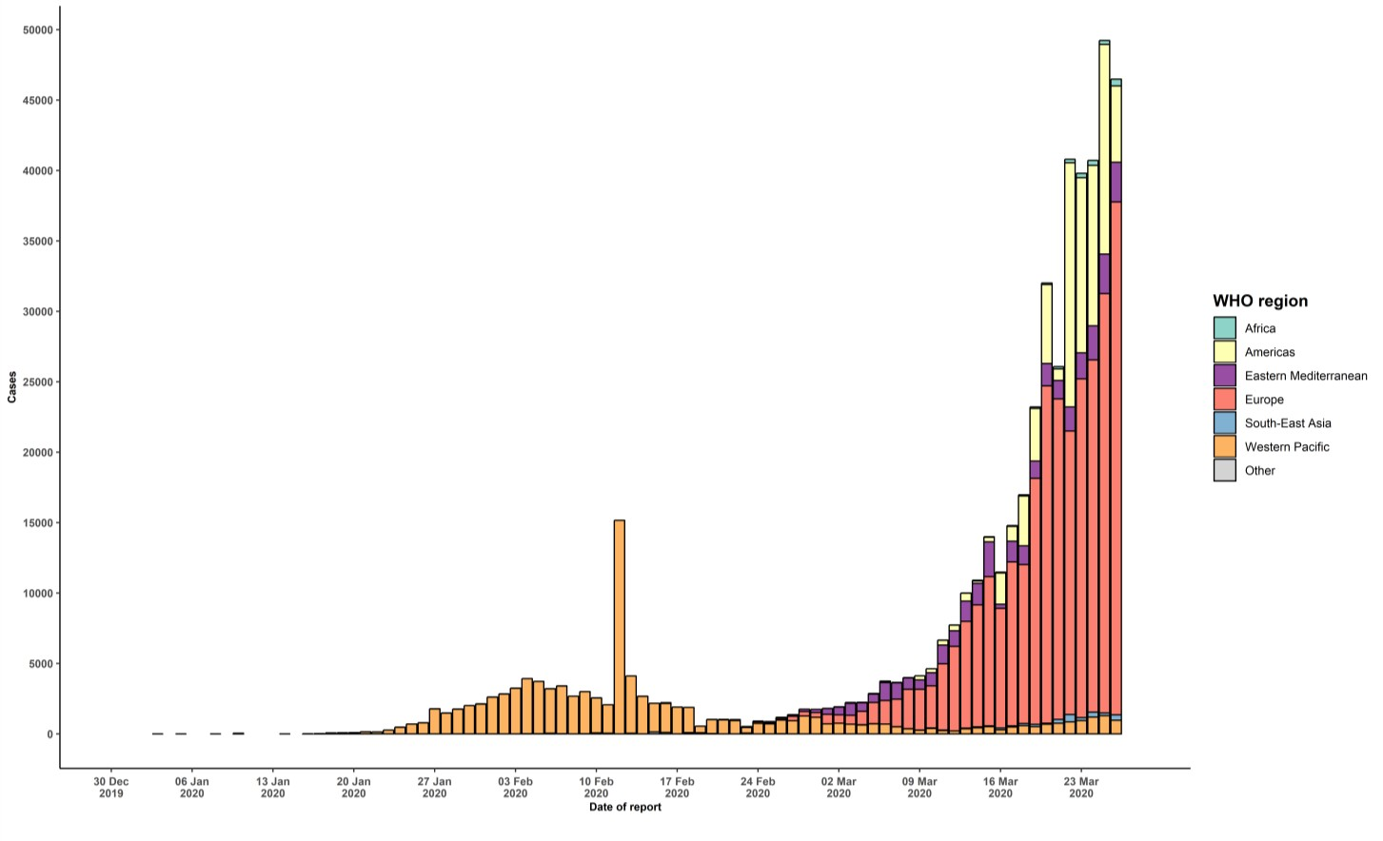

STRATEGIC OBJECTIVES

WHO’s strategic objectives for this response are to:

  - Interrupt human-to-human transmission including reducing secondary infections among close contacts and health care workers, preventing transmission amplification events, and preventing further international spread*;
  - Identify, isolate and care for patients early, including providing optimized care for infected patients;
  - Identify and reduce transmission from the animal source;
  - Address crucial unknowns regarding clinical severity, extent of transmission and infection, treatment options, and accelerate the development of diagnostics, therapeutics and vaccines;
  - Communicate critical risk and event information to all communities and counter misinformation;
  - Minimize social and economic impact through multisectoral partnerships.

*This can be achieved through a combination of public health measures, such as rapid identification, diagnosis and management of the cases, identification and follow up of the contacts, infection prevention and control in health care settings, implementation of health measures for travelers, awareness-raising in the population and risk communication.
PREPAREDNESS AND RESPONSE
- To view all technical guidance documents regarding COVID-19, please go to this webpage.
- WHO has developed interim guidance for laboratory diagnosis, advice on the use of masks during home care and in health care settings in the context of the novel coronavirus (2019-nCoV) outbreak, clinical management, infection prevention and control in health care settings, home care for patients with suspected novel coronavirus, risk communication and community engagement and Global Surveillance for human infection with novel coronavirus (2019-nCoV).
- WHO is working closely with International Air Transport Association (IATA) and have jointly developed a guidance document to provide advice to cabin crew and airport workers, based on country queries. The guidance can be found on the IATA webpage.
- WHO has been in regular and direct contact with Member States where cases have been reported. WHO is also informing other countries about the situation and providing support as requested.
- WHO is working with its networks of researchers and other experts to coordinate global work on surveillance, epidemiology, mathematical modelling, diagnostics and virology, clinical care and treatment, infection prevention and control, and risk communication. WHO has issued interim guidance for countries, which are updated regularly.
- WHO has prepared a disease commodity package that includes an essential list of biomedical equipment, medicines and supplies necessary to care for patients with 2019-nCoV.
- WHO has provided recommendations to reduce risk of transmission from animals to humans.
- WHO has published an updated advice for international traffic in relation to the outbreak of the novel coronavirus 2019-nCoV.
- WHO has activated the R&D blueprint to accelerate diagnostics, vaccines, and therapeutics.
- OpenWHO is an interactive, web-based, knowledge-transfer platform offering online courses to improve the response to health emergencies. COVID-19 courses can be found here and courses in additional national languages here. Specifically, WHO has developed online courses on the following topics:
  - A general introduction to emerging respiratory viruses, including novel coronaviruses (available in Arabic, Chinese, English, French, Russian, Spanish, Hindi, Indian Sign Language, Persian, Portuguese, Serbian and Turkish);
  - Clinical care for Severe Acute Respiratory Infections (available in English, French, Russian, Indonesian and Vietnamese);
  - Health and safety briefing for respiratory diseases - ePROTECT (available in Chinese, English, French, Russian, Spanish, Indonesian and Portuguese);
  - Infection Prevention and Control for Novel Coronavirus (COVID-19) (available in Chinese, English, French,
Russian, Spanish, Indonesian, Italian, Japanese, Portuguese and Serbian); and
  - COVID-19 Operational Planning Guidelines and COVID-19 Partners Platform to support country preparedness and response (available in English and coming soon in additional languages).
- WHO is providing guidance on early investigations, which are critical in an outbreak of a new virus. The data collected from the protocols can be used to refine recommendations for surveillance and case definitions, to characterize the key epidemiological transmission features of COVID-19, help understand spread, severity, spectrum of disease, impact on the community and to inform operational models for implementation of countermeasures such as case isolation, contact tracing and isolation. Several protocols are available here. One such protocol is for the investigation of early COVID-19 cases and contacts (the “First Few X (FFX) Cases and contact investigation protocol for 2019-novel coronavirus (2019-nCoV) infection”). The protocol is designed to gain an early understanding of the key clinical, epidemiological and virological characteristics of the first cases of COVID-19 infection detected in any individual country, to inform the development and updating of public health guidance to manage cases and reduce the potential spread and impact of infection.
RECOMMENDATIONS AND ADVICE FOR THE PUBLIC

If you are not in an area where COVID-19 is spreading or have not travelled from an area where COVID-19 is spreading or have not been in contact with an infected patient, your risk of infection is low. It is understandable that you may feel anxious about the outbreak. Get the facts from reliable sources to help you accurately determine your risks so that you can take reasonable precautions (see Frequently Asked Questions). Seek guidance from WHO, your healthcare provider, your national public health authority or your employer for accurate information on COVID-19 and whether COVID-19 is circulating where you live. It is important to be informed of the situation and take appropriate measures to protect yourself and your family (see Protection measures for everyone).

If you are in an area where there are cases of COVID-19 you need to take the risk of infection seriously. Follow the advice of WHO and guidance issued by national and local health authorities. For most people, COVID-19 infection will cause mild illness however, it can make some people very ill and, in some people, it can be fatal. Older people, and those with pre-existing medical conditions (such as cardiovascular disease, chronic respiratory disease or diabetes) are at risk for severe disease (See Protection measures for persons who are in or have recently visited (past 14 days) areas where COVID-19 is spreading).

CASE DEFINITIONS

WHO periodically updates the Global Surveillance for human infection with coronavirus disease (COVID-19) document which includes case definitions.

For easy reference, case definitions are included below.

Suspect case
- A patient with acute respiratory illness (fever and at least one sign/symptom of respiratory disease, e.g., cough, shortness of breath), AND a history of travel to or residence in a location reporting community transmission of COVID-19 disease during the 14 days prior to symptom onset.
OR
- A patient with any acute respiratory illness AND having been in contact with a confirmed or probable COVID-19 case (see definition of contact) in the last 14 days prior to symptom onset;
OR
- A patient with severe acute respiratory illness (fever and at least one sign/symptom of respiratory disease, e.g., cough, shortness of breath; AND requiring hospitalization) AND in the absence of an alternative diagnosis that fully explains the clinical presentation.

Probable case
- A suspect case for whom testing for the COVID-19 virus is inconclusive.
  - Inconclusive being the result of the test reported by the laboratory.
OR
- A suspect case for whom testing could not be performed for any reason.

Confirmed case
A person with laboratory confirmation of COVID-19 infection, irrespective of clinical signs and symptoms.
- Technical guidance for laboratory testing can be found here.

Definition of contact
A contact is a person who experienced any one of the following exposures during the 2 days before and the 14 days
after the onset of symptoms of a probable or confirmed case:
- Face-to-face contact with a probable or confirmed case within 1 meter and for more than 15 minutes;
- Direct physical contact with a probable or confirmed case;
- Direct care for a patient with probable or confirmed COVID-19 disease without using proper personal protective equipment1; OR
- Other situations as indicated by local risk assessments.

Note: for confirmed asymptomatic cases, the period of contact is measured as the 2 days before through the 14 days
after the date on which the sample was taken which led to confirmation.

1 World Health Organization. Infection prevention and control during health care when COVID-19 is suspected https://www.who.int/publications-detail/infection-prevention-and-control-during-health-care-when-novel-coronavirus-(ncov)- infection-is-suspected-20200125

